### MODULE 1 : What is Data Engineering

### 📊 ****Introduction to Data Engineering – Course Summary****

This foundational course is the first in a series aimed at preparing learners for a career as a **Junior Data Engineer**. It highlights the explosive growth of data and its critical role in decision-making across industries, governments, and institutions.

#### 🚀 Why Data Engineering?

* Data engineering ensures **accurate** and **efficient access** to data.
* It's one of the **fastest-growing tech roles**, with a 50% year-over-year growth according to the Dice Tech Job Report (2020).

#### 👥 Who Is This Course For?

* Aspiring data engineers from **any background**—engineering, computer science, non-tech, or self-taught coders.
* **Working professionals** looking to upskill.
* **Data professionals** interested in engineering roles.

#### 📚 What You'll Learn:

* Core concepts and **life cycle of data engineering**
* **Data repositories**, **pipelines**, **integration platforms**, and **big data**
* **Architecture and design** of data platforms and stores
* **ETL processes**: Extract, Transform, Load
* **Data cleaning** for analytics
* **Security, privacy**, and **compliance principles**

#### 🎓 Expert Insights:

The course features guidance from seasoned data engineers and industry leaders who share practical advice and career pathways.

**🌐 Modern Data Ecosystem – Summary**

**📈 Data Growth & Evolution**

* Data is expanding rapidly due to faster processing speeds, broader bandwidth, and new tools for creation and consumption.
* Forbes (2020) describes this as a “virtuous cycle” where data continuously generates more data.

**🧩 Components of the Ecosystem**

* A modern data ecosystem is a **network of interconnected, evolving entities**.
* It includes:
  + **Diverse data sources** (structured & unstructured)
  + **Analytical skills** to derive insights
  + **Stakeholders** who act on insights
  + **Tools & infrastructure** for storage, processing, and sharing

**🗂️ Data Sources**

* Data comes from:
  + Text, images, videos
  + Clickstreams, user conversations
  + Social media, IoT devices
  + Real-time event streams
  + Legacy databases & professional data providers

**🏗️ Data Acquisition & Preparation**

* First step: **Pull data into a repository** from original sources.
* Challenges include:
  + Handling formats, interfaces
  + Ensuring reliability, security, and integrity
* Next steps:
  + **Organize, clean, and optimize** data
  + Ensure **compliance** with regulations (e.g., personal data standards)
  + Align with **master data tables** for consistency

**🔐 Data Management & Access**

* Repositories must offer:
  + High **availability**, **flexibility**, **security**, and **accessibility**
* Stakeholders include:
  + Data analysts (need raw data)
  + Business users (need dashboards)
  + Applications (need APIs)

**🚀 Emerging Technologies**

* Key enablers:
  + **Cloud Computing**: scalable storage & computing
  + **Machine Learning**: predictive modeling
  + **Big Data**: handling massive, varied datasets
* Traditional tools are insufficient, leading to new methods and insights.

## 🔑 Key Players in the Data Ecosystem

Organizations rely on a diverse set of professionals to transform raw data into strategic insights. Each role contributes uniquely to the data lifecycle:

### 🏗️ Data Engineers

* **Role**: Build and maintain data architecture.
* **Tasks**: Extract, clean, transform, and store data from various sources.
* **Skills**: Programming, database management, system architecture.

### 📊 Data Analysts

* **Role**: Translate data into actionable insights.
* **Tasks**: Inspect, clean, analyze, and visualize data.
* **Skills**: Spreadsheets, SQL, statistical tools, storytelling.

### 🤖 Data Scientists

* **Role**: Predict future trends using past data.
* **Tasks**: Build machine learning models, identify patterns, forecast outcomes.
* **Skills**: Math, statistics, programming, domain expertise.

### 🧭 Business Analysts

* **Role**: Interpret insights to guide business decisions.
* **Tasks**: Assess implications of data findings, recommend actions.
* **Focus**: Internal business operations and strategy.

### 🌐 BI (Business Intelligence) Analysts

* **Role**: Analyze external market forces and trends.
* **Tasks**: Monitor business functions, extract insights, improve performance.
* **Focus**: Competitive landscape and external influences.

### 🧩 How They Work Together

* **Data Engineers** prepare the foundation.
* **Data Analysts** uncover insights.
* **Data Scientists** forecast the future.
* **Business & BI Analysts** turn insights into decisions.

These roles often overlap, and professionals may transition between them by expanding their skillsets. Together, they form a powerful ecosystem that drives data-driven innovation.

## 📚 Summary: Specializations in the Data Engineering Ecosystem

This lecture explores four key roles in the data engineering ecosystem—each with distinct responsibilities, tools, and collaborative functions. These professionals work together to ensure efficient, secure, and scalable data management across organizations.

### 🧑‍💼 Key Roles & Responsibilities

| **Role** | **Primary Focus** | **Core Responsibilities** | **Tools Used** |
| --- | --- | --- | --- |
| **Data Warehouse Engineer** | Design and maintain data warehouses for BI and reporting | - Develop ETL pipelines<br>- Implement data lakes<br>- Enable structured access for analytics | Apache Kafka, Spark, Cloud DW solutions |
| **Data Architect** | Design scalable data architecture across platforms | - Define integration, governance, and security strategies<br>- Model relationships<br>- Plan for growth | ERD tools, MySQL, MongoDB, Cloud platforms |
| **Data Manager** | Oversee governance and strategic alignment of data | - Develop policies and standards<br>- Ensure compliance<br>- Promote data literacy | Data governance platforms |
| **Database Administrator** | Ensure secure, reliable, and high-performing database operations | - Conduct backups<br>- Monitor performance<br>- Implement encryption and disaster recovery | SQL, Database monitoring tools |

### 🏥 Real-World Example: Hospital Network

| **Role** | **Contribution in Healthcare Context** |
| --- | --- |
| **Data Warehouse Engineer** | Integrates patient data from EHR and lab systems; builds ETL pipelines for analytics and reporting |
| **Data Architect** | Designs scalable structure for millions of records; enables secure and rapid data retrieval |
| **Data Manager** | Ensures regulatory compliance; aligns IT operations with clinical goals |
| **Database Administrator** | Maintains EHR system uptime; safeguards sensitive data; implements disaster recovery protocols |

### 🤝 Collaboration & Interdependencies

* **Warehouse Engineers** work with architects and managers to ensure pipelines meet governance and design standards.
* **Architects** collaborate with engineers and DBAs to implement scalable systems.
* **Managers** coordinate across business and technical teams to align data strategy.
* **DBAs** rely on architects for system design and managers for compliance enforcement.

### 🌐 Importance in the Data Ecosystem

| **Role** | **Strategic Contribution** |
| --- | --- |
| **Data Warehouse Engineer** | Ensures structured, accessible data for BI and analytics |
| **Data Architect** | Builds adaptable ecosystems for evolving business needs |
| **Data Manager** | Aligns data strategy with organizational goals |
| **Database Administrator** | Maintains reliability, security, and performance of data systems |

These roles form the backbone of modern data infrastructure. Understanding their distinctions and synergies helps professionals choose a path that aligns with their strengths and aspirations in the data-driven era.

## 📊 Summary: What Is Data Engineering?

Data Engineering is the backbone of the modern data ecosystem. It focuses on the **flow, access, ­­**

### 🔧 Core Functions of Data Engineering

| **Stage** | **Key Activities** |
| --- | --- |
| **Data Collection** | - Extract, integrate, and organize data from disparate sources |
|  | - Develop tools, workflows, and processes for acquiring data |
| **Data Architecture** | - Design, build, and maintain scalable storage systems (databases, warehouses, lakes) |
| **Data Processing** | - Clean, transform, and prepare data for usability |
|  | - Implement distributed systems for large-scale processing |
|  | - Build ETL pipelines and validate data quality, privacy, and security |
| **Data Storage** | - Architect data stores for processed data |
|  | - Ensure scalability, privacy, compliance, monitoring, backup, and recovery |
| **Data Access** | - Provide secure access via APIs, services, dashboards |
|  | - Implement rights-based access and user interfaces for insights |

### 🧠 Key Insights

* **Data Engineering is a team sport**: No single person is expected to master all tools and technologies.
* **Specialized skills** include:
  + Architecture design
  + Database management
  + Programming and distributed systems
* **Tools and solutions** vary by organization and can be on-premise or cloud-based.

### 🎯 Purpose & Impact

* Builds **robust and scalable infrastructure** for data availability.
* Enables **data manipulation** through advanced tools and technologies.
* Supports **decision-making** by ensuring data is clean, secure, and accessible.

## Responsibilities and skillsets of a data engineer — summary

### Purpose and outcome

* **Overarching goal:** Deliver analytics-ready data that is accurate, reliable, compliant, and available when needed.
* **What “analytics-ready” means:** Data that is cleaned, governed, secured, and structured for easy consumption by downstream users and systems.

### Core responsibilities

* **Data acquisition:** Extract, organize, and integrate data from disparate sources.
* **Data preparation:** Transform and cleanse data for analysis and reporting.
* **Pipelines:** Design and manage end-to-end data pipelines from source to destination.
* **Infrastructure:** Set up and operate ingestion, processing, and storage platforms (databases, warehouses, lakes, distributed systems).
* **Access enablement:** Provide secure access via APIs, services, and interfaces with rights-based controls.

### Technical skills

| **Domain** | **Examples** |
| --- | --- |
| **Operating systems** | UNIX, Linux, Windows; admin tools, utilities, commands |
| **Infra & cloud** | VMs, networking, load balancers, APM; AWS, GCP, IBM Cloud, Azure |
| **Databases** | RDBMS: IBM Db2, MySQL, Oracle, PostgreSQL; NoSQL: Redis, MongoDB, Cassandra, Neo4j |
| **Data warehousing** | Oracle Exadata, IBM Db2 Warehouse on Cloud, Netezza, Amazon Redshift |
| **Pipelines & orchestration** | Apache Beam, Airflow, Dataflow |
| **ETL/ELT tools** | IBM InfoSphere, AWS Glue, Improvado |
| **Languages** | SQL and SQL-like for NoSQL; Python, R, Java; Bash/Unix shell, PowerShell |
| **Big data processing** | Hadoop, Hive, Spark |

Tip: Knowing comparable tools helps evaluate trade-offs and make sound recommendations.

### Functional skills

* **Requirements translation:** Convert business needs into technical specifications.
* **SDLC proficiency:** Work across ideation, architecture, design, prototyping, testing, deployment, and monitoring.
* **Business context:** Understand how data drives value in products and operations.
* **Risk awareness:** Anticipate and mitigate risks around data quality, privacy, security, and compliance.

### Collaboration and soft skills

* **Team play:** Coordinate with other data engineers, analysts, data scientists, business users, and platform teams.
* **Communication:** Explain technical concepts clearly to both technical and non-technical stakeholders.
* **Cross-functional alignment:** Ensure pipelines and platforms meet governance, reliability, and usability expectations.

### Growth and specialization

* **T‑shaped development:** Specialize in one or more areas (e.g., pipelines, platforms, warehousing) while maintaining broad literacy across the stack.
* **Continuous upskilling:** Skills deepen with experience, focused learning paths, and evolving toolchains.

**MODULE 2 : Data Engineering Ecosystem**

# Overview of the Data Engineering Ecosystem — Summary

This lecture defines the scope of a data engineer’s ecosystem: the infrastructure, tools, frameworks, and processes that power the flow, transformation, storage, and delivery of data for analytics and decision-making.

## 1. Core Components

* **Infrastructure & Frameworks** Servers, clusters, cloud services, distributed systems, and orchestration tools that underpin data ingestion, processing, and storage.
* **Data Pipelines** Architected workflows (ETL or ELT) that extract data from sources, transform/cleanse it, then load it into target repositories.
* **Data Repositories** Databases, data warehouses, data lakes, and marts optimized for transactional or analytical workloads.
* **Integration & Automation** Tools and processes that combine disparate data into unified views, automate repetitive tasks, and enforce quality, security, and compliance.
* **Access Layers** APIs, dashboards, and BI/reporting tools that present data to end users with rights-based controls.

## 2. Data Types

| **Category** | **Structure** | **Examples** |
| --- | --- | --- |
| **Structured** | Rigid rows & columns | Relational tables, spreadsheets |
| **Semi-structured** | Mix of defined fields + free-form content | JSON/XML, emails |
| **Unstructured** | Qualitative, no fixed schema | Images, videos, PDFs, social feed |

## 3. Data Repositories

| **Repository Type** | **Purpose** | **Examples** |
| --- | --- | --- |
| **OLTP** | High-volume transactional operations | Banking apps, reservation systems |
| **OLAP** | Complex analytics and reporting | Data warehouses, data lakes, big-data stores |

## 4. Data Integration & Pipelines

* **Integration Tools** Combine and present unified views (e.g., Informatica, Talend, custom scripts).
* **Pipeline Patterns**
  + Extract → Transform → Load (ETL)
  + Extract → Load → Transform (ELT)
* **Automation & Orchestration** Frameworks like Apache Airflow, AWS Data Pipeline, or cloud-native workflows.

## 5. Languages & BI Tools

* **Query Languages** SQL, SQL-like dialects for NoSQL.
* **Programming & Scripting** Python, Java, R, shell/bash, PowerShell.
* **BI & Reporting** Drag-and-drop dashboards (Tableau, Power BI) for real-time and scheduled visualizations.

## 6. Ecosystem Characteristics

* **Diversity of Tools** Multiple comparable solutions exist—selection depends on trade-offs in performance, cost, and scale.
* **Team Sport** No single engineer masters all areas; specialization (architecture, pipelines, storage) plus broad literacy is key.
* **Continuous Evolution** As data volume, variety, and velocity grow, the ecosystem expands with new patterns, technologies, and best practices.

# Types of Data — Summary

## Data Definition

Data is unorganized information that is processed to make it meaningful. It comprises facts, observations, perceptions, numbers, characters, symbols, and images that can be interpreted to derive insights.

## Classification by Structure

| **Category** | **Structure** | **Storage** | **Sources / Examples** |
| --- | --- | --- | --- |
| Structured | Rigid schema, organized in rows and columns | Relational / SQL databases | OLTP systems, spreadsheets, online forms, GPS/RFID sensors, server logs |
| Semi-structured | Partial schema with tags or metadata | Document stores (XML/JSON), NoSQL | Emails, XML/JSON files, binary executables, zipped files, TCP/IP packets |
| Unstructured | No predefined schema or fixed format | File systems, NoSQL databases, data lakes | Web pages, social media feeds, images (JPEG, GIF, PNG), video/audio files, documents (PDF, PowerPoint), surveys |

## Storage & Analysis Considerations

Structured data fits neatly into relational databases and can be queried with standard SQL and analyzed using traditional BI tools.

Semi-structured data uses metadata (tags, attributes) to impose hierarchy, and it resides in document-oriented stores or NoSQL systems where it’s parsed by schema‐aware processors.

Unstructured data lacks inherent organization, so it’s typically stored as files or in specialized NoSQL/data lake environments and analyzed via full-text search engines, machine learning models, or manual review.

## Key Takeaways

* The level of schema definition dictates the storage mechanism and analysis approach.
* Structured data is the easiest to store and query, semi-structured balances flexibility with some organization, and unstructured offers maximum flexibility at the cost of more complex processing.
* Choosing the right repository and tools depends on the data’s structure, volume, and intended analytics use case.

# Summary of Common File Formats

## Overview

Data professionals encounter diverse file formats, each with unique structures, advantages, and constraints. Understanding these formats ensures optimal storage, processing performance, and compatibility with tools.

## Delimited Text Files

* Store rows of data as plain text with values separated by a delimiter (e.g., comma, tab, pipe).
* Common types: CSV (comma-separated values) and TSV (tab-separated values).
* First row typically contains column headers; subsequent rows represent records.
* Benefits: universally supported, simple schema definition, any field length.
* Limitation: lack of native support for nested or hierarchical data.

## Microsoft Excel Open XML Spreadsheet (XLSX)

* XML-based spreadsheet format supporting multiple worksheets within a single workbook.
* Organized into rows, columns, and cells; each cell can contain various data types.
* Open format allows broad application compatibility and retains all Excel functions.
* Security advantage: cannot embed executable code, reducing malware risk.

## Extensible Markup Language (XML)

* Self-descriptive markup language with user-defined tags for encoding hierarchical data.
* Human- and machine-readable; platform- and language-independent.
* Commonly used for data interchange between systems without predefined tag sets (unlike HTML).

## Portable Document Format (PDF)

* Designed to present documents consistently across software, hardware, and operating systems.
* Widely used in legal, financial, and form-fill applications.
* Ensures fixed layout and typography, but not optimized for data extraction or analysis.

## JavaScript Object Notation (JSON)

* Text-based, language-independent format for transmitting structured data over the web.
* Represents data as key-value pairs and arrays, supporting nested structures.
* Lightweight and easy to parse in most programming environments.
* Ubiquitous in modern APIs and web services for returning complex data, including multimedia references.

## Choosing the Right Format

* Delimited text for simple, tabular data; maximum tool compatibility.
* XLSX when end-users need rich spreadsheet functionality and formula support.
* XML for interoperable, hierarchical data exchange between heterogeneous systems.
* PDF for fixed-layout document distribution, not for analytics.
* JSON for web APIs, dynamic data interchange, and hierarchical data structures.

Further exploration of specialized and binary formats (e.g., Parquet, Avro, ORC) will follow in the next module

# Sources of Data — Lecture Summary

Data in today’s ecosystems comes from a rich variety of internal and external origins. Understanding each source type helps you choose the right ingestion method, storage, and processing tools.

## 1. Relational Databases

* **Where it lives**: Internal business applications (e.g., retail transactions, CRM, HR systems).
* **Examples**: SQL Server, Oracle, MySQL, IBM DB2.
* **Use cases**: Ad hoc querying of sales by region, customer behavior analysis.

## 2. Flatfiles & XML Datasets

* **Flatfiles**: Plain-text, row-per-line with delimiters (commas, tabs, pipes).
  + Common formats: CSV, TSV.
  + Maps to a single table.
* **Spreadsheets**: Tabular data with multiple sheets, formulas, formatting.
  + Formats: .XLS, .XLSX (Excel), Google Sheets.
* **XML**: Hierarchical, tag-based structure for complex records.
  + Used in surveys, bank statements, custom data exchange.

## 3. APIs & Web Services

* **Function**: Listen for requests and return data programmatically.
* **Formats**: JSON, XML, HTML, media files.
* **Examples**:
  + Social APIs (Twitter, Facebook) for sentiment analysis
  + Stock-market feeds (prices, EPS, history)
  + Lookup/Validation (e.g., ZIP-to-City)

## 4. Web Scraping

* **Also known as**: Screen scraping, web harvesting.
* **Purpose**: Extract unstructured content (text, images, videos) from web pages.
* **Use cases**: Price comparisons, lead generation, forum mining, ML dataset creation.
* **Tools**: BeautifulSoup, Scrapy, Selenium, pandas.

## 5. Data Streams & Feeds

* **Characteristics**: Continuous, timestamped, often geo-tagged.
* **Sources**: IoT sensors, GPS devices, application logs, social-media firehose, clickstreams, flight event feeds.
* **Use cases**: Real-time trading, demand forecasting, surveillance, sentiment monitoring, web analytics.
* **Platforms**: Apache Kafka, Spark Streaming, Apache Storm
* **RSS Feeds**: Pull ongoing updates from news sites and forums via feed readers.

## Comparative Table

| **Source Category** | **Data Shape** | **Common Formats** | **Tools / Platforms** |
| --- | --- | --- | --- |
| Relational Databases | Structured rows & columns | SQL | JDBC/ODBC, database client libraries |
| Flatfiles & Spreadsheets | Tabular, single/multi-sheet | CSV, TSV, XLSX | Built-in parsers, pandas |
| XML Datasets | Hierarchical tag-based | XML | XML parsers, XSLT |
| APIs/Web Services | Request-response payloads | JSON, XML, HTML, media | REST clients, curl, Postman |
| Web Scraping | Unstructured web content | HTML, images, text | BeautifulSoup, Scrapy, Selenium |
| Data Streams & Feeds | Continuous event streams | Kafka topics, RSS XML | Kafka, Spark Streaming, Storm |

**Key Takeaway:**   
Selecting the optimal ingestion and storage strategy hinges on understanding each source’s structure, volume, and access patterns. With this foundation, you can architect pipelines that efficiently capture and deliver data for downstream analytics.

# Summary: Languages for Data Professionals

Data professionals rely on three language categories—query, programming, and shell/scripting—to access, manipulate, and automate data workflows. Proficiency in at least one language per category is essential.

## 1. Language Categories & Roles

| **Category** | **Typical Languages** | **Primary Purpose** |
| --- | --- | --- |
| Query Languages | SQL | Accessing and manipulating data in databases |
| Programming Languages | Python, R, Java | Building applications, data processing, analytics, and modeling |
| Shell/Scripting | Unix/Linux Shell, PowerShell | Automating repetitive tasks and orchestrating system operations |

## 2. Query Language: SQL

* Designed for relational (and some non-relational) databases.
* Core operations: **SELECT**, INSERT, UPDATE, DELETE, CREATE (tables, views), and stored procedures.
* Advantages:
  + Portable across platforms with minor dialect variations
  + Simple, English-like syntax for rapid prototyping
  + Efficient retrieval of large datasets via interpreters
  + Large community and extensive documentation

## 3. Programming Languages

### Python

* High-level, general-purpose, open-source language with a gentle learning curve.
* Strengths in data tasks:
  + Libraries: **Pandas**, **NumPy**, **SciPy** for data manipulation and statistics
  + **Matplotlib**, **Seaborn** for visualization
  + **BeautifulSoup**, **Scrapy** for web scraping
  + **OpenCV** for image processing
* Supports multiple paradigms (object-oriented, functional, procedural).

### R

* Open-source language and environment specifically for statistics and visualization.
* Key benefits:
  + Rich plotting libraries: **ggplot2**, **Plotly**
  + Built-in support for structured and unstructured data
  + Extensible through user-defined functions and packages
  + Integration with web apps and embedded reporting (e.g., Shiny)

### Java

* Object-oriented, class-based, and platform-independent.
* Ubiquitous in big data ecosystems: frameworks like **Hadoop**, **Hive**, and **Spark** are Java-based.
* Suited for speed-critical and large-scale data processing.

## 4. Shell & Scripting Languages

### Unix/Linux Shell

* Plain-text scripts of shell commands for automating OS-level tasks.
* Ideal for file manipulation, batch jobs, system backups, and log processing.

### PowerShell

* Object-based shell and scripting framework for Windows (cross-platform support available).
* Excels at handling structured formats (JSON, CSV, XML) and REST APIs.
* Enables filtering, sorting, grouping, and building interactive reports or GUIs.

### Key Takeaways

* **SQL** remains the universal query language for databases.
* **Python** and **R** dominate data science, with Python offering broad application support and R excelling in statistical graphics.
* **Java** underpins many big data tools where performance is critical.
* **Shell scripting** (Unix/Linux or PowerShell) streamlines repetitive operations and pipeline orchestration.
* Building fluency across these categories empowers data professionals to design, develop, and automate end-to-end data workflows.

# Metadata and Metadata Management

# Objectives

After completing this reading, you will be able to:

* Define what metadata is
* Describe what metadata management is
* Explain the importance of metadata management
* List popular tools for metadata management

# What is metadata?

Metadata is data that provides information about other data.

This is a very broad definition. Here we will consider the concept of metadata within the context of databases, data warehousing, business intelligence systems, and all kinds of data repositories and platforms.

We'll consider the following three main types of metadata:

* Technical metadata
* Process metadata, and
* Business metadata

## Technical metadata

Technical metadata is metadata which defines the data structures in data repositories or platforms, primarily from a technical perspective.

For example, technical metadata in a data warehouse includes assets such as:

* Tables that record information about the tables stored in a database, like:
  + each table's name
  + the number of columns and rows each table has
* A data catalog, which is an inventory of tables that contain information, like:
  + the name of each database in the enterprise data warehouse
  + the name of each column present in each database
  + the names of every table that each column is contained in
  + the type of data that each column contains

The technical metadata for relational databases is typically stored in specialized tables in the database called the System Catalog.

## Process metadata

Process metadata describes the processes that operate behind business systems such as data warehouses, accounting systems, or customer relationship management tools.

Many important enterprise systems are responsible for collecting and processing data from various sources. Such critical systems need to be monitored for failures and any performance anomalies that arise. Process metadata for such systems includes tracking things like:

* process start and end times
* disk usage
* where data was moved from and to, and
* how many users access the system at any given time

This sort of data is invaluable for troubleshooting and optimizing workflows and ad hoc queries.

## Business metadata

Users who want to explore and analyze data within and outside the enterprise are typically interested in data discovery. They need to be able to find data which is meaningful and valuable to them and know where that data can be accessed from. These business-minded users are thus interested in business metadata, which is information about the data described in readily interpretable ways, such as:

* how the data is acquired
* what the data is measuring or describing
* the connection between the data and other data sources

Business metadata also serves as documentation for the entire data warehouse system.

# Managing metadata

Managing metadata includes developing and administering policies and processes to ensure information can be accessed and integrated from various sources and appropriately shared across the entire enterprise.

Creation of a reliable, user-friendly data catalog is a primary objective of a metadata management model. The data catalog is a core component of a modern metadata management system, serving as the main asset around which metadata management is administered. It serves as the basis by which companies can inventory and efficiently organize their data systems. A modern metadata management model will include a web-based user interface that enables engineers and business users to easily search for and find information on key attributes such as CustomerName or ProductType. This kind of model is central to any Data Governance initiative.

# Why is metadata management important?

Good metadata management has many valuable benefits. Having access to a well implemented data catalog greatly enhances data discovery, repeatability, governance, and can also facilitate access to data.

Well managed metadata helps you to understand both the business context associated with the enterprise data and the data lineage, which helps to improve data governance. Data lineage provides information about the origin of the data and how it gets transformed and moved, and thus it facilitates tracing of data errors back to their root cause. Data governance is a data management concept concerning the capability that enables an organization to ensure that high data quality exists throughout the complete lifecycle of the data, and data controls are implemented that support business objectives.

The key focus areas of data governance include availability, usability, consistency, data integrity and data security and includes establishing processes to ensure effective data management throughout the enterprise such as accountability for the adverse effects of poor data quality and ensuring that the data which an enterprise has can be used by the entire organization.

# Popular tools for metadata management

Popular metadata management tools include:

* IBM InfoSphere Information Server
* CA Erwin Data Modeler
* Oracle Warehouse Builder
* SAS Data Integration Server
* Talend Data Fabric
* Alation Data Catalog
* SAP Information Steward
* Microsoft Azure Data Catalog
* IBM Watson Knowledge Catalog
* Oracle Enterprise Metadata Management (OEMM)
* Adaptive Metadata Manager
* Unifi Data Catalog
* data.world
* Informatica Enterprise Data Catalog

# Summary

In this reading, you learned that:

* Metadata is data that provides information about other data, and includes three main types: technical, process, and business metadata
* The technical metadata for relational databases is typically stored in specialized tables in the database called the system catalog
* A primary objective of business metadata management modelling is the creation and maintenance of a reliable, user-friendly data catalog
* Having access to a well-implemented data catalog greatly enhances data discovery, repeatability, governance, and can also facilitate access to data
* Metadata management tools from IBM include InfoSphere Information Server and Watson Knowledge Catalog.

Here’s a structured summary of the lecture titled **“Overview of Data Repositories”** from the Introduction to Data Engineering course:

## 🗃️ Summary: Overview of Data Repositories

Data repositories are centralized infrastructures where data is collected, organized, and stored for business operations, reporting, and analytics. They vary in structure, scale, and purpose, and include databases, data warehouses, and big data stores.

### 🔍 Types of Data Repositories

| **Repository Type** | **Description** | **Key Features & Use Cases** |
| --- | --- | --- |
| **Databases** | Structured collections of data managed by a DBMS | - Input, storage, retrieval, and modification of data<br>- Used for operational tasks like customer records or transactions |
| **Relational (RDBMS)** | Tabular format with rows and columns; uses SQL | - Schema-based<br>- Optimized for multi-table queries<br>- Examples: MySQL, Oracle, SQL Server |
| **Non-relational (NoSQL)** | Schema-less, flexible format for high-volume, diverse data | - Built for scalability and speed<br>- Ideal for big data and real-time apps<br>- Examples: MongoDB, Cassandra |
| **Data Warehouses** | Centralized repositories for analytics and BI | - Consolidates data via ETL<br>- Supports historical analysis<br>- Examples: Amazon Redshift, Snowflake |
| **Big Data Stores** | Distributed systems for massive datasets | - Scalable compute and storage<br>- Used for IoT, social media, and sensor data<br>- Examples: Hadoop HDFS, Apache Hive |

### 🔄 ETL Process (Extract, Transform, Load)

* **Extract**: Pull data from multiple sources
* **Transform**: Clean and format data for analysis
* **Load**: Store data into a centralized repository (e.g., warehouse)

### 🧠 Key Insights

* **DBMS vs. Database**: DBMS is the software managing the database; terms often used interchangeably.
* **Repository Choice Factors**: Data type, structure, latency, transaction speed, and intended use.
* **Evolution**: Traditional repositories were relational; modern needs have introduced NoSQL and distributed systems.

### 🏁 Purpose of Data Repositories

* Enable efficient querying and analytics
* Serve as archives for historical data
* Improve credibility and consistency in reporting
* Support scalable, secure, and flexible data access

Here’s a **structured, concise, and detailed summary** of the lecture you just shared on **Relational Databases (RDBMS)**:

## 🗄 Relational Databases (RDBMS) — Overview

A **relational database** organizes data into **tables** (rows = records, columns = attributes) that can be **linked** via common fields (keys).  
Example:

* **Customer Table** → Company ID, Name, Address, Phone
* **Transaction Table** → Transaction Date, Customer ID, Amount, Payment Method  
  Linked via **Customer ID** to produce combined reports.

### 🔑 Core Concepts

| **Concept** | **Description** | **Benefit** |
| --- | --- | --- |
| **Tables & Relationships** | Tables linked by common fields (Primary & Foreign Keys) | Enables joining data for richer insights |
| **SQL** | Standard query language for RDBMS | Efficient querying, filtering, and aggregation |
| **Schema** | Predefined structure of tables, columns, and data types | Ensures consistency and integrity |
| **Data Types & Constraints** | Restrict values in fields | Improves data quality |
| **Security Architecture** | Controlled access & governance | Protects sensitive data |

### ⚡ Advantages

| **Advantage** | **Details** |
| --- | --- |
| **Flexibility** | Add/modify tables, columns, and relationships while live |
| **Reduced Redundancy** | Store data once, reference via keys |
| **Backup & Recovery** | Easy export/import; cloud DBs offer continuous mirroring |
| **ACID Compliance** | **A**tomicity, **C**onsistency, **I**solation, **D**urability — reliable transactions |
| **Performance** | Handles millions of records in seconds |
| **Maturity** | Well-documented, large talent pool |

### ☁ Deployment Models

* **On-Premise**: Open-source (PostgreSQL, MySQL) or commercial (Oracle, SQL Server, IBM DB2)
* **Cloud (DBaaS)**: Amazon RDS, Google Cloud SQL, Azure SQL, IBM DB2 on Cloud

### 📊 Common Use Cases

| **Use Case** | **Why RDBMS Fits** |
| --- | --- |
| **OLTP** (Online Transaction Processing) | High-volume, concurrent transactions with fast response |
| **OLAP** (Data Warehousing) | Historical data analysis for BI |
| **IoT Solutions** | Lightweight, fast ingestion from edge devices |

### ⚠ Limitations

* Poor fit for **semi-structured** (JSON, XML) and **unstructured** (images, video, text) data
* Schema & data types must match for migration between RDBMSs
* Field length limits can truncate data
* Less suited for large-scale analytics on diverse big data

### 🧠 Key Takeaway

Despite the rise of NoSQL and big data technologies, **RDBMS remains the dominant choice for structured data** due to its reliability, maturity, and strong transactional guarantees.

Here’s a **clear, structured summary** of your NoSQL lecture notes:

## 🗄 ****NoSQL Databases — Overview****

**Definition:**   
NoSQL = “Not Only SQL” — a **non-relational** database design with **flexible schemas** for storing and retrieving structured, semi-structured, and unstructured data.

* Popular in the **cloud, big data, and high-volume web/mobile** era.
* Built for **scale, performance, and ease of use**.
* Schema-less or free-form storage; often **does not use SQL** (though some support SQL-like queries).

## 📦 ****Types of NoSQL Databases****

| **Type** | **Structure & Storage** | **Best For** | **Limitations** | **Examples** |
| --- | --- | --- | --- | --- |
| **Key-Value Store** | Data stored as key–value pairs; key = unique identifier | Session data, user preferences, caching, targeted ads | Poor for complex queries or relationships | Redis, Memcached, DynamoDB |
| **Document-Based** | Each record stored as a document (e.g., JSON, BSON) | eCommerce, medical records, CRM, analytics | Not ideal for complex joins or multi-step transactions | MongoDB, DocumentDB, CouchDB, Cloudant |
| **Column-Based** | Data stored in columns grouped into **column families** | Heavy write loads, time-series, IoT, weather data | Less suited for complex/frequent query pattern changes | Cassandra, HBase |
| **Graph-Based** | Nodes = entities, Edges = relationships | Social networks, fraud detection, recommendations, network diagrams | Not optimized for high-volume analytics queries | Neo4j, CosmosDB |

## 🚀 ****Advantages of NoSQL****

* Handles **large volumes** of diverse data types.
* **Distributed systems** across multiple data centers → leverage cloud scalability.
* **Scale-out architecture**: add nodes for more capacity/performance.
* **Agility & flexibility**: rapid iteration, simpler design, better availability control.

## 🔍 ****RDBMS vs NoSQL — Key Differences****

| **Feature** | **RDBMS** | **NoSQL** |
| --- | --- | --- |
| **Schema** | Rigid, predefined | Flexible, schema-agnostic |
| **Data Types** | Structured only | Structured, semi-structured, unstructured |
| **Scaling** | Vertical (scale-up) | Horizontal (scale-out) |
| **Cost** | High for enterprise-grade | Designed for low-cost commodity hardware |
| **ACID Compliance** | Yes (strong transactional guarantees) | Often relaxed for performance/scalability |
| **Maturity** | Very mature, well-documented | Newer, evolving rapidly |

## 🧠 ****Key Takeaway****

NoSQL emerged to overcome RDBMS limitations in handling **big, fast, and varied data**. While it trades some transactional guarantees for flexibility and scalability, it’s now widely used in **mission-critical applications** alongside — not instead of — relational databases.

Here’s a clear, structured summary of your lecture on **Data Warehouses, Data Marts, and Data Lakes**:

## 🗂 Overview

All three are **data mining repositories** designed to store data for **reporting, analysis, and insights**, but they differ in **purpose, data types stored, and access methods**.

## 1️⃣ Data Warehouse

**Definition:**   
A **central repository** integrating data from multiple sources, serving as the **single source of truth**.

* Stores **current and historical** data that is **cleansed, conformed, and categorized**.
* Traditionally relational (CRM, ERP, HR, Finance), but now also supports **NoSQL**.

**Architecture (3-tier):**

1. **Bottom tier** – Database servers (relational, non-relational, or both) extract data from sources.
2. **Middle tier** – OLAP server for processing and analysis.
3. **Top tier** – Client front-end tools for querying, reporting, and analytics.

**Cloud Benefits:**   
Lower cost, unlimited storage/compute, pay-as-you-go scaling, faster disaster recovery.

**When to Use:**   
For **large volumes of operational data** that must be readily available for analytics.

**Examples:**   
Teradata, Oracle Exadata, IBM Db2 Warehouse on Cloud, Amazon Redshift, Google BigQuery, Snowflake.

## 2️⃣ Data Mart

**Definition:**   
A **subset** of a data warehouse, focused on a **specific business function** or user group (e.g., Sales, Finance).

**Types:**

* **Dependent** – Extracted from an enterprise data warehouse (already cleaned/transformed).
* **Independent** – Built from operational or external sources (requires own transformation).
* **Hybrid** – Combines warehouse, operational, and external data.

**Purpose & Benefits:**

* Provides **relevant data quickly** to specific teams.
* Improves **response times** and decision-making.
* Offers **isolated security** and performance.

## 3️⃣ Data Lake

**Definition:**   
A repository for **raw, native-format** data — structured, semi-structured, and unstructured.

* No need to define schema before loading.
* Data is transformed **only when needed** for a specific use case.
* Still requires **classification, protection, and governance**.

**Deployment Options:**

* Cloud object storage (Amazon S3)
* Distributed systems (Apache Hadoop)
* RDBMS or NoSQL systems

**Benefits:**

* Stores **all data types** (JSON, XML, CSV, logs, documents, images, etc.)
* Scales from terabytes to petabytes
* Saves time by skipping upfront schema design
* Enables **data repurposing** for multiple future use cases

**Vendors:**   
Amazon, Cloudera, Google, IBM, Microsoft, Oracle, SAS, Snowflake, Teradata, Zaloni.

## 📊 Quick Comparison

| **Feature** | **Data Warehouse** | **Data Mart** | **Data Lake** |
| --- | --- | --- | --- |
| **Scope** | Enterprise-wide | Department/function-specific | All enterprise data (raw) |
| **Data State** | Cleaned & structured | Structured (cleaned or raw) | Raw, native format |
| **Schema** | Defined before load | Defined before load | Defined on read |
| **Best For** | Historical analysis, BI | Targeted analytics | Data science, exploration |
| **Tech Examples** | Redshift, Snowflake | Subset of DW | S3, Hadoop |

Here’s a **clear, structured summary** of your Data Lakehouse Explained lecture, using the restaurant analogy from the video:

## 🍽 Restaurant Analogy for Data Architecture

* **Raw ingredients** arriving at a restaurant = **Raw data** entering an organization from multiple sources (cloud apps, operational systems, social media, etc.).
* **Loading dock** = **Data Lake** — a low-cost, scalable place to quickly store all types of raw data (structured, semi-structured, unstructured) for later use.
* **Sorting, labeling, and storing ingredients** = **Data transformation & organization** — preparing data for analysis.
* **Pantries & freezers** = **Enterprise Data Warehouse (EDW)** — cleaned, organized, governed, and trusted data optimized for analytics.

## 🗂 Data Lake vs Data Warehouse

| **Feature** | **Data Lake** | **Data Warehouse** |
| --- | --- | --- |
| **Purpose** | Capture raw data cheaply & quickly | Store curated, structured data for analytics |
| **Data Types** | Structured, semi-structured, unstructured | Primarily structured (limited semi-structured) |
| **Strengths** | Flexible, scalable, cost-effective | High query performance, strong governance |
| **Challenges** | Risk of becoming a “data swamp” (poor quality, duplicates, stale data), slower queries | High cost, limited unstructured data support, slower for real-time needs |

## ⚠ Challenges in the Traditional Approach

* **Data Lakes**:
  + Governance & quality issues → can degrade into “data swamps”
  + Query performance not optimized for complex analytics
* **Data Warehouses**:
  + Expensive to scale
  + Limited support for growing semi/unstructured data
  + Latency in loading fresh data

## 🆕 Data Lakehouse — Best of Both Worlds

**Definition:**   
A hybrid architecture combining the **flexibility & low cost** of a data lake with the **performance & structure** of a data warehouse.

**Benefits:**

* Store diverse data types from many sources at low cost
* Built-in **data management & governance**
* Supports **BI workloads** and **high-performance ML/AI**
* Enables modernization of existing lakes and complements warehouses

**Use Cases:**

* Modernizing legacy data lakes
* Extending warehouse capabilities for AI/ML
* Handling both historical analytics and real-time insights

**Key Takeaway:**   
A **data lakehouse** is like having a kitchen storage system that’s as cheap and flexible as a loading dock but as organized and high-performing as a pantry or freezer — enabling both **fast, governed analytics** and **innovative AI/ML workloads**.

Here’s a **clear, structured summary** of your lecture on **ETL, ELT, and Data Pipelines**:

## 🔄 Overview

Data movement from source to destination systems can be achieved through:

* **ETL** – Extract, Transform, Load
* **ELT** – Extract, Load, Transform
* **Data Pipelines** – The broader framework encompassing both ETL and ELT

## 1️⃣ ETL (Extract → Transform → Load)

**Purpose:** Convert raw data into **analysis-ready** data before loading into a repository.

**Steps:**

1. **Extract** – Gather data from sources
   * **Batch processing**: Large chunks at scheduled intervals (e.g., Stitch, Blendo)
   * **Stream processing**: Real-time ingestion & transformation in transit (e.g., Apache Samza, Apache Storm, Apache Kafka)
2. **Transform** – Apply rules/functions to clean & standardize data
   * Normalize formats (dates, units)
   * Remove duplicates, filter irrelevant data
   * Enrich data (e.g., split full name into first/middle/last)
   * Apply business rules, validations, and relationships
3. **Load** – Move processed data into target system
   * **Initial load** – Populate repository from scratch
   * **Incremental load** – Apply periodic updates
   * **Full refresh** – Wipe and reload
   * Includes **load verification** (null checks, performance monitoring, recovery mechanisms)

**Tools:** IBM Infosphere, AWS Glue, Improvado, Skyvia, HEVO, Informatica PowerCenter

## 2️⃣ ELT (Extract → Load → Transform)

**Variation:** Load raw data into the target system **first**, then transform it there.

**Best For:**

* Large, unstructured, or non-relational datasets
* Data lakes (but can also target warehouses)

**Advantages:**

* Faster ingestion (no staging step)
* Immediate availability of raw data
* Greater flexibility for analysts/data scientists
* Transform only what’s needed for a given analysis
* Well-suited for **big data** and exploratory analytics

## 3️⃣ Data Pipelines

**Definition:** End-to-end systems that move data between systems — ETL and ELT are **subsets**.

**Characteristics:**

* Can be **batch**, **streaming**, or hybrid
* Streaming pipelines process continuously (e.g., IoT sensor data, traffic monitoring)
* Support both **long-running batch queries** and **interactive queries**
* Destinations: Data lakes, applications, visualization tools

**Tools:** Apache Beam, Apache Airflow, Google Dataflow

## 📊 Quick Comparison

| **Feature** | **ETL** | **ELT** |
| --- | --- | --- |
| **Transform Stage** | Before loading | After loading |
| **Best For** | Structured data, warehouses | Big data, data lakes |
| **Speed** | Slower ingestion | Faster ingestion |
| **Flexibility** | Less flexible for new use cases | Highly flexible |
| **Processing** | External ETL engine | Target system (e.g., cloud warehouse/lake) |

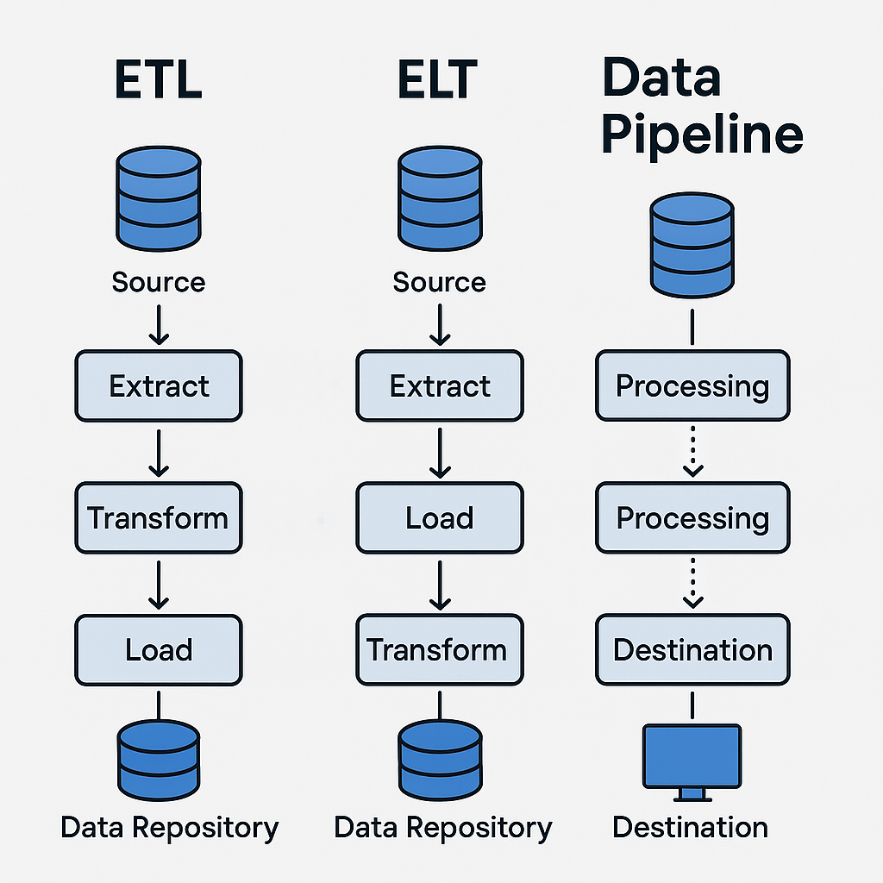

## ****📌 Data Integration – Definition & Scope****

* **Gartner Definition**:  
  Discipline involving **practices, architectural techniques, and tools** to ingest, transform, combine, and provision data across various data types.
* **Usage Scenarios**:
  + Data consistency across applications
  + Master Data Management (MDM)
  + Data sharing between enterprises
  + Data migration & consolidation

## ****🔍 Role in Analytics & Data Science****

* **Processes involved**:
  + Accessing, queueing, or extracting data from operational systems
  + Transforming & merging data (logical or physical)
  + Ensuring data quality & governance
  + Delivering integrated data for analytics
* **Example**:  
  Extract customer data from sales, marketing, and finance → unify into a single view → enable querying, analytics, and visualization.

## ****🔗 Relationship with ETL & Data Pipelines****

| **Concept** | **Scope** | **Role in Data Integration** |
| --- | --- | --- |
| **Data Integration** | Combines disparate data into a unified view | Core discipline |
| **Data Pipeline** | End-to-end movement of data from source to destination | Used to perform data integration |
| **ETL** | Extract, Transform, Load process | A process within data integration |

## ****⚙️ Capabilities of Modern Data Integration Platforms****

* **Connectivity**: Pre-built connectors/adapters for databases, flat files, APIs, CRM, ERP, social media, etc.
* **Architecture**: Open-source for flexibility & avoiding vendor lock-in.
* **Processing Modes**: Supports batch, streaming, or both.
* **Big Data Integration**: Native support for large-scale data sources.
* **Additional Features**:
  + Data quality & governance
  + Compliance & security
  + Portability across on-prem, single cloud, multi-cloud, hybrid cloud

## ****🏢 Vendor Examples****

**Commercial Tools**:

* **IBM**: Information Server, Cloud Pak for Data, Cloud Pak for Integration, Data Replication, Data Virtualization Manager, Info Sphere Data Stage
* **Talend**: Data Fabric, Talend Cloud, Data Catalog, Data Management, Big Data, Data Services, Open Studio
* Others: SAP, Oracle, Denodo, SAS, Microsoft, Qlik, TIBCO

**Open-Source / Frameworks**:

* Dell Boomi, Jitterbit, SnapLogic

**Cloud-based iPaaS**:

* Adeptia Integration Suite
* Google Cloud’s Cooperation 534
* IBM Application Integration Suite on Cloud
* Informatica’s Integration Cloud

## ****📈 Trends****

* Growing importance of **cloud-native** and **multi-cloud** capabilities
* Increasing demand for **real-time streaming integration**
* Emphasis on **data governance, compliance, and security**
* Expansion of **iPaaS offerings** as hosted services

Here’s a structured summary of the lecture titled **“Foundations of Big Data”**:

## 📊 What Is Big Data?

* **Definition (Ernst & Young):**   
  Big Data refers to dynamic, large, and disparate volumes of data created by people, tools, and machines. It requires scalable technologies to collect, host, and analyze data for real-time insights across business domains.
* **Key Purpose:**   
  To derive insights that impact consumers, risk, profit, performance, productivity, and shareholder value.

## 🔁 The 5 V’s of Big Data

| **V** | **Description** | **Examples** |
| --- | --- | --- |
| **Velocity** | Speed at which data is generated and processed | Real-time streaming (e.g., YouTube uploads every minute) |
| **Volume** | Scale of data generated daily | ~2.5 quintillion bytes/day from billions of devices |
| **Variety** | Diversity of data types and sources | Text, images, video, IoT, wearables, social media |
| **Veracity** | Accuracy, consistency, and reliability of data | 80% of data is unstructured; requires validation and governance |
| **Value** | Ability to extract meaningful insights | Business, medical, social, and personal benefits |

## 🧠 Challenges & Solutions

* **Challenge:**   
  Traditional tools can't handle the scale and complexity of Big Data.
* **Solution:**   
  Distributed computing frameworks like:
  + **Apache Spark**
  + **Hadoop ecosystem**

These tools enable scalable extraction, transformation, and analysis across multiple nodes.

## 🌍 Real-World Impact

* Big Data enables organizations to:
  + Personalize services
  + Improve customer engagement
  + Make data-driven decisions
* Everyday devices (smart phones, wearables) contribute to global data flows that return as insights through analytics.

Here’s **visual info-graphic** of the **5 V’s of Big Data** — ready to make the concept stick at a glance:

**side ‑by ‑side diagram** it connects each of the **5 V’s of Big Data** directly to the **real‑ world tools** and frameworks that data engineers use to handle them:

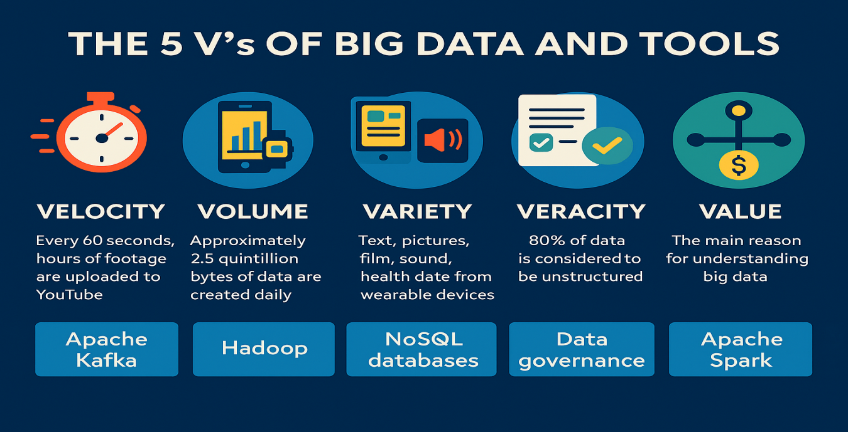

This graphic breaks each V into:

* **Velocity** → Speed of data generation (e.g., YouTube uploads every minute)
* **Volume** → Massive scale (2.5 quintillion bytes/day)
* **Variety** → Different formats & sources (text, images, IoT, wearables)
* **Veracity** → Data quality & trustworthiness (80% unstructured)
* **Value** → Turning data into meaningful insights

**🗂 How to Read This Diagram**

| **V** | **What It Means** | **Example Tool(s)** | **Why This Tool Fits** |
| --- | --- | --- | --- |
| **Velocity** | Speed of data generation & processing | **Apache Kafka** | Handles high‑ throughput, real‑ time data streams |
| **Volume** | Massive scale of stored data | **Hadoop (HDFS)** | Distributed storage for petabyte‑ scale datasets |
| **Variety** | Multiple formats & sources | **NoSQL DBs** (MongoDB, Cassandra) | Flexible schemas for structured, semi‑structured, and unstructured data |
| **Veracity** | Accuracy & trustworthiness | **Data Governance Tools** (Apache Atlas, Collibra) | Ensure data quality, lineage, and compliance |
| **Value** | Turning data into insights | **Apache Spark** | Distributed analytics & machine learning at scale |

## 📌 Big Data Processing Technologies Overview

These open-source tools handle **structured, semi-structured, and unstructured** data at scale, enabling organizations to derive value from Big Data.

## 🛠 The Three Core Technologies

| **Technology** | **Purpose** | **Key Features** | **Best For** |
| --- | --- | --- | --- |
| **Apache Hadoop** | Distributed storage & processing framework | - Java-based, open-source<br>- Scales from 1 node to 100s<br>- Handles any data format<br>- Cost-effective storage | Storing & processing massive datasets across clusters |
| **HDFS** (Hadoop Distributed File System) | Storage layer of Hadoop | - Splits large files across nodes<br>- Parallel processing<br>- Replication for fault tolerance (default: 3 copies)<br>- Data locality for efficiency | Reliable, scalable storage for Big Data |
| **Apache Hive** | Data warehouse on top of Hadoop | - SQL-like queries (HiveQL)<br>- Works with HDFS & HBase<br>- High latency (batch-oriented)<br>- Read-heavy workloads | ETL, reporting, analytics on large datasets |
| **Apache Spark** | Distributed data processing engine | - In-memory computation for speed<br>- Supports Java, Scala, Python, R, SQL<br>- Works standalone or with Hadoop<br>- Handles batch, streaming, ML, ETL | Real-time analytics, machine learning, stream processing |

## 🔍 Key Concepts & Benefits

### ****Hadoop****

* **Cluster-based**: Nodes = individual computers; clusters = many nodes.
* **Data flexibility**: Can store structured, semi-structured, and unstructured data.
* **Cost optimization**: Move “cold” data from expensive systems to Hadoop.
* **No format restrictions**: Accepts emerging formats like IoT streams, social media, clickstreams.

### ****HDFS****

* **Parallelism**: Splits files into blocks for simultaneous processing.
* **Fault tolerance**: Replicates blocks to prevent data loss.
* **Data locality**: Moves computation to where data resides, reducing network load.
* **Scalable & portable**: Works across hardware platforms and OSs.

### ****Hive****

* **SQL interface**: Makes Big Data accessible to analysts.
* **Batch-oriented**: Not suitable for low-latency or transactional workloads.
* **Integration**: Reads from HDFS or HBase.

### ****Spark****

* **In-memory speed**: Faster than disk-based systems.
* **Versatility**: Batch, streaming, ML, and graph processing.
* **Integration**: Reads from HDFS, Hive, and many other sources.

## 📊 How They Work Together in a Pipeline

1. **Data Ingestion** → Raw data lands in **HDFS** (via Hadoop).
2. **Storage & Management** → HDFS stores and replicates data.
3. **Batch Querying** → **Hive** runs SQL-like queries for analytics.
4. **Real-Time Processing** → **Spark** handles streaming and advanced analytics.

Here’s your **full end‑to‑end Big Data ecosystem diagram** — now expanded to show the **entire pipeline** from data sources all the way to visualization tools:

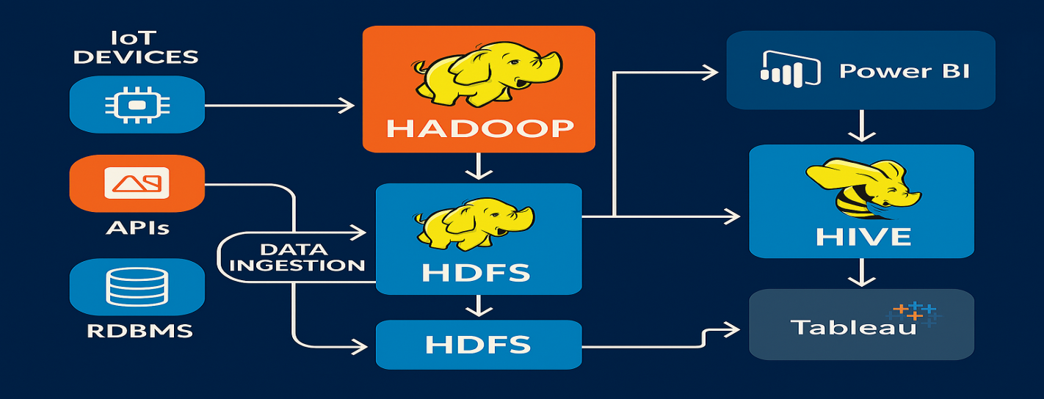

**📊 How the Pipeline Flows**

1. **Data Sources**
   * **IoT Devices** → Sensors, wearables, smart appliances
   * **APIs** → Social media feeds, web services, external datasets
   * **RDBMS** → Traditional relational databases
2. **Data Ingestion Layer**
   * Collects and streams raw data into the processing ecosystem.
3. **Hadoop Framework**
   * **Core orchestration** for distributed storage & processing.
4. **HDFS (Hadoop Distributed File System)**
   * Splits, replicates, and stores data across cluster nodes for fault tolerance and parallelism.
5. **Hive**
   * SQL-like querying for batch analytics, ETL, and reporting.
6. **Spark**
   * Real-time analytics, machine learning, and stream processing with in-memory speed.
7. **Visualization & BI Tools**
   * **Power BI** and **Tableau** turn processed data into dashboards, reports, and interactive insights.

**MODULE 3 : Data Engineering LifeCycle**

## 🏗 Layers of a Data Platform Architecture

### 1. ****Data Ingestion / Data Collection Layer****

**Purpose:** Bring data from source systems into the data platform.  
**Key Tasks:**

* Connect to data sources.
* Transfer data in **batch**, **streaming**, or **hybrid** modes.
* Maintain metadata (e.g., batch size, source, descriptive info).

**Example Tools:**

* **Cloud & Streaming:** Google Cloud DataFlow, IBM Streams, IBM Streaming Analytics on Cloud, Amazon Kinesis, Apache Kafka.

### 2. ****Data Storage & Integration Layer****

**Purpose:** Store data for processing and long-term use; integrate data from multiple sources.  
**Key Tasks:**

* Store data reliably, scalably, cost-effectively.
* Transform & merge data (logical or physical integration).
* Make data available for batch & streaming processing.

**Example Tools:**

* **Relational Databases:** IBM DB2, Microsoft SQL Server, MySQL, Oracle DB, PostgreSQL.
* **Cloud RDBaaS:** IBM DB2 on Cloud, Amazon RDS, Google Cloud SQL, SQL Azure.
* **NoSQL Databases:** IBM Cloudant, Redis, MongoDB, Cassandra, Neo4J.
* **Integration Tools:** IBM Cloud Pak for Data, IBM Cloud Pak for Integration, Talend Data Fabric/Open Studio, Dell Boomi, SnapLogic.
* **iPaaS Vendors:** Adeptia Integration Suite, Google Cloud’s Cooperation 534, IBM Application Integration Suite on Cloud, Informatica Integration Cloud.

### 3. ****Data Processing Layer****

**Purpose:** Validate, transform, and apply business logic to data.  
**Key Capabilities:**

* Read from storage in batch or streaming mode.
* Apply transformations.
* Support popular query tools & programming languages.
* Scale with dataset growth.
* Provide access for analysts & data scientists.

**Common Transformations:**

* **Structuring:** Change schema or field order; combine fields (joins/unions).
* **Normalization:** Remove redundancy/inconsistency.
* **De-normalization:** Merge tables for faster querying.
* **Data Cleaning:** Fix irregularities for credible downstream use.

**Example Tools:**

* Spreadsheets, Open-Refine, Google Data-Prep, Watson Studio Refinery, Trifacta Wrangler.
* **Programming:** Python, R (with data processing libraries).

**Note:**

* Storage & processing may be combined (e.g., RDBMS).
* In Big Data: store in HDFS → process in Spark.
* Sometimes processing occurs **before** storage (ETL).

### 4. ****Analysis & User Interface Layer****

**Purpose:** Deliver processed data to consumers.  
**Data Consumers:**

* BI analysts & business stakeholders (dashboards, reports).
* Data scientists & analysts (further processing).
* Applications/services needing data input.

**Capabilities:**

* Querying tools (SQL, CQL for Cassandra).
* Programming languages (Python, R, Java).
* APIs for online/offline reporting & real-time consumption.
* Dashboarding & BI tools: IBM Cognos Analytics, Tableau, Jupyter Notebooks, Python/R libraries, Microsoft Power BI.

### 5. ****Data Pipeline Layer**** (Overlay)

**Purpose:** Implement & maintain continuous data flow across ingestion, storage, and processing.  
**Example Tools:** Apache Airflow, DataFlow.

✅ **Key Takeaway:**   
This architecture is a **simplified model** of a complex system that supports a wide range of data tasks, from ingestion to analysis, with the **Data Pipeline** ensuring smooth, continuous movement between layers.

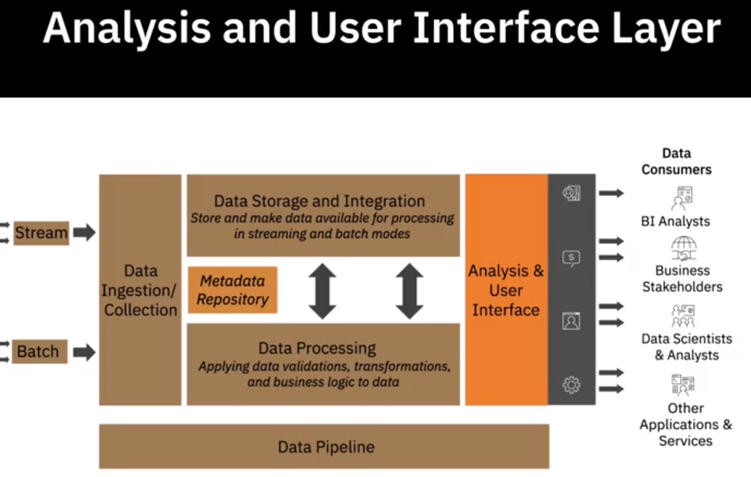

# Factors for Selecting and Designing Data Stores :

## 📌 ****Definition & Purpose****

* **Data Store / Data Repository**: Collected, organized, and isolated data for business operations, reporting, and analytics.
* Examples: **Database**, **Data Warehouse**, **Data Mart**, **Big Data Store**, **Data Lake**.
* **Goal**: Scalability, high performance under heavy workloads.

## 🛠 ****Primary Design Considerations****

1. **Type of Data**
   * **Relational (RDBMS)**: Structured data, fixed schema, tabular format.
   * **Non-relational (NoSQL)**: Semi-structured/unstructured, schema-less.
     + Types: **Key-Value**, **Document**, **Column**, **Graph**.
     + Match type to query/transaction needs.
2. **Volume of Data**
   * **Data Lake**: Large-scale raw data (relational + non-relational), schema defined later.
   * **Big Data Store**: High-volume, high-velocity, diverse data; distributed processing; parallel computation.
3. **Intended Use**
   * **Transactional Systems (OLTP)**: High-speed read/write/update for large transaction volumes.
   * **Analytical Systems (OLAP)**: Complex queries on aggregated historical data; fast query response.
   * Schema design, indexing, partitioning impact performance.
4. **Scalability**
   * Ability to handle growth in data, workloads, and users.
5. **Normalization**
   * Efficient data organization to save space, ease maintenance, and speed access.
   * **Best for**: Transactional systems.
   * **Caution**: Over-normalization can hurt analytical query performance.

## 💾 ****Storage Considerations****

* **Performance**:
  + Throughput: Rate of read/write operations.
  + Latency: Time to access specific data.
* **Availability**: Always accessible, no downtime.
* **Integrity**: Protection from corruption, loss, or attack.
* **Recoverability**: Ability to restore data after failures/disasters.

## 🔐 ****Privacy, Security & Governance****

* **Secure Data Strategy**: Layered approach with:
  + Access control
  + Multi-zone encryption
  + Data management
  + Monitoring systems
* **Regulatory Compliance**:
  + GDPR, CCPA, HIPAA
  + Controlled data flow
  + Multiple data protection techniques
* **Best Practice**: Integrate privacy/security/governance **from the start** to avoid patchwork fixes.

✅ **Key Takeaway**:  
Designing a data store requires aligning **data type**, **volume**, **usage patterns**, **scalability**, **storage performance**, and **security/governance** to business needs — with technology choices tailored to each factor.

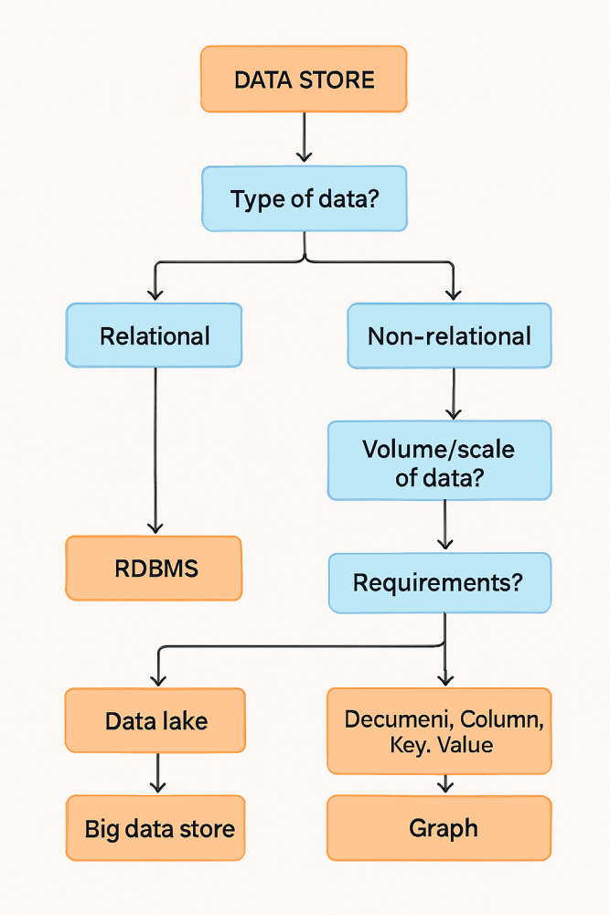

**🗂 Decision Tree: Choosing the Right Data Store**

**Start →** **What type of data do you have?**

* **Structured (fixed schema, tabular)** → **Relational Database (RDBMS)**
  + Best for: Transactional systems, strong consistency, complex joins.
* **Semi-structured / Unstructured (schema-less, flexible)** → **NoSQL**
  + Next: **What’s your primary need?**
    - **High-volume raw data storage (any type)** → **Data Lake**
      * Store data in native format, schema-on-read, scalable.
    - **High-volume + high-velocity + diverse + distributed processing** → **Big Data Store**
      * Parallel processing, large-scale analytics.
    - **Specific query/relationship needs**:
      * **Key-Value** → Simple lookups, caching.
      * **Document** → Flexible JSON/XML docs, moderate complexity queries.
      * **Column** → Wide tables, analytical queries.
      * **Graph** → Complex relationships, network analysis.

**Then consider:**

* **Usage**: OLTP (fast read/write) v-s OLAP (complex queries).
* **Scalability**: Growth in data, workloads, users.
* **Normalization**: Good for OLTP, avoid over-normalization in OLAP.
* **Storage Factors**: Performance, Availability, Integrity, Recoverability.
* **Security & Governance**: Build in compliance (GDPR, CCPA, HIPAA) from the start.

## 🔑 ****Core Security Principle – CIA Triad****

| **Component** | **Purpose** | **Example Controls** |
| --- | --- | --- |
| **Confidentiality** | Prevent unauthorized access | Access control, encryption |
| **Integrity** | Ensure data/resources are trustworthy and un-tampered | Checksums, digital signatures |
| **Availability** | Ensure authorized users can access resources when needed | Redundancy, failover systems |

The CIA triad applies to **all security layers**: infrastructure, network, application, and data.

## 🛡 ****Four Facets / Levels of Security****

### 1. ****Physical Infrastructure Security****

* **Scope**: Data centers, cloud provider facilities.
* **Measures**:
  + Perimeter access control + 24/7 surveillance.
  + Multiple power feeds from independent providers.
  + Generators + UPS battery backup.
  + Heating/cooling systems for temperature & humidity control.
  + Location risk assessment (avoid flood plains, earthquake zones).
  + Earthquake-resistant structures.
  + Multi-level lightning protection & earthing systems.

### 2. ****Network Security****

* **Goal**: Protect interconnected systems and data in transit.
* **Techniques**:
  + **Firewalls**: Block unauthorized internet access.
  + **Network Access Control**: Only authorized, compliant devices connect.
  + **Network Segmentation**: Create VLANs/silos for different security levels.
  + **Security Protocols**: Encrypt data in transit.
  + **IDS/IPS**: Detect and prevent intrusion attempts.

### 3. ****Application Security****

* **Goal**: Keep customer data private, ensure app performance.
* **Practices**:
  + **Threat Modeling**: Identify weaknesses & attack patterns.
  + **Secure Design**: Mitigate risks early.
  + **Secure Coding**: Follow guidelines to prevent vulnerabilities.
  + **Security Testing**: Detect & fix issues before deployment.

### 4. ****Data Security****

* **States of Data**:
  + **At Rest**: Stored in DBs, warehouses, backups, devices.
    - Control: Encryption to prevent disclosure if lost/stolen.
  + **In Transit**: Moving between systems/services.
    - Control: HTTPS, SSL, TLS encryption.
* **Access Control**:
  + **Authentication**: Verify identity (passwords, tokens, biometrics).
  + **Authorization**: Role-based access to resources.

## 📊 ****Ongoing Security Management****

* **End-to-End Visibility**: Monitor, track, and respond to violations quickly.
* **Security Monitoring & Intelligence**:
  + Audit history for compliance & triage.
  + Alerts & reports for timely response.
* **Corporate Security Policy**:
  + Involves **people, policies, processes, systems, tools**.
  + Aligns business, IT, and stakeholders toward security goals.

### ****Summary Diagram – Security Layers****

CIA Triad

├── Physical Infrastructure Security

├── Network Security

├── Application Security

└── Data Security

├── At Rest → Encryption, Access Control

└── In Transit → HTTPS, SSL, TLS

## 📌 ****Data Gathering Methods & Tools****

### 1. ****Database Queries****

* **Relational Databases (RDBMS)** → Query via **SQL**:
  + Retrieve specific data, specify source table, group by matching values, order results, limit output.
* **Non-relational (No-SQL)**:
  + May support SQL or have their own query languages:
    - **CQL** (Cassandra)
    - **Graph-QL** (Neo4J)

### 2. ****APIs (Application Programming Interfaces)****

* Access data via an **endpoint** (DB, web service, marketplace).
* Used for **data extraction** and **validation**.
  + Example: Validate postal addresses and ZIP codes.

### 3. ****Web Scraping****

* Also called **screen scraping** or **web harvesting**.
* Extracts data (text, images, videos, contacts, product info) from web pages using set parameters.

### 4. ****RSS Feeds****

* Capture **continually updated** data from forums, news sites.

### 5. ****Data Streams****

* Continuous flow from:
  + Instruments
  + IoT devices & apps
  + GPS-enabled devices
  + Social media feeds
* Common in **real-time analytics** scenarios.

### 6. ****Data Exchange Platforms****

* Enable data sharing between providers & consumers.
* Enforce **standards, security, governance**:
  + Licensing workflows
  + Privacy protection (de-identification)
  + Legal frameworks
  + Quarantined analytics environments
* **Examples**: AWS Data Exchange, Crunchbase, Lotame, Snowflake

### 7. ****Other Sources****

* Market trends & research: Forrester, Business Insider
* Strategic guidance: Gartner, Forrester
* Behavioral data: Surveys, demographic studies, web/app usage stats

## 📦 ****Importing Data into Repositories****

### Process:

* Combine data from multiple sources into a **single view** & unified query interface.
* Choice of method/tool depends on **data type**, **volume**, **destination repository**.

### ****Repository Types & Data Suitability****

| **Data Type** | **Examples** | **Storage Options** |
| --- | --- | --- |
| **Structured** (rigid schema) | OLTP data, spreadsheets, online forms, sensor logs | Relational DBs, No-SQL |
| **Semi-Structured** (some organization) | Emails, XML, JSON, zipped files, binaries, TCP/IP logs | No-SQL clusters, XML/JSON stores |
| **Unstructured** (no fixed schema) | Web pages, social media, images, videos, docs, media logs | No-SQL DBs, Data Lakes |

## ⚙ ****Import Tools****

* **ETL Tools & Pipelines**:
  + **Talend**, **Informatica**
* **Programming Languages**:
  + **Python**, **R** (plus relevant libraries)

✅ **Key Takeaway:**   
Data gathering spans from **direct querying** to **real-time feeds** and **data exchanges**. Matching the right **extraction method** and **import pipeline** to **data type and repository** is critical for efficiency and scalability.

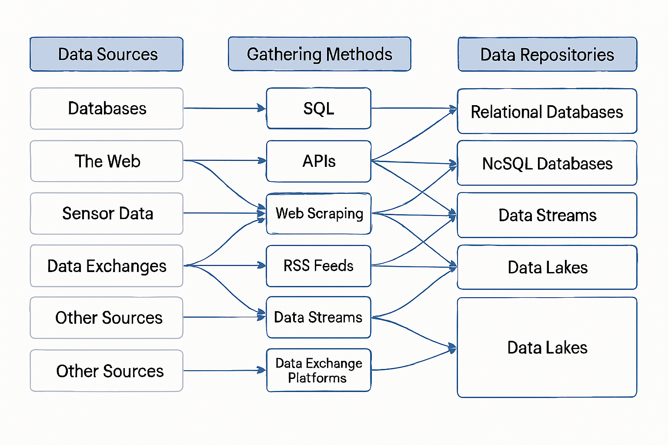

%% Links: Data Sources → Methods

A1 --> B1

A1 --> B2

A2 --> B3

A2 --> B4

A3 --> B2

A3 --> B5

A4 --> B6

A5 --> B4

A6 --> B5

A7 --> B2

A7 --> B6

%% Links: Methods → Repositories

B1 --> C1

B1 --> C2

B2 --> C1

B2 --> C2

B2 --> C3

B3 --> C3

B4 --> C2

B4 --> C3

B5 --> C2

B5 --> C3

B6 --> C1

B6 --> C2

B6 --> C3

**🔍 How to Read This**

* **Yellow boxes** = Original *data sources*.
* **Blue boxes** = *Gathering tools/methods* that fetch or validate data.
* **Green boxes** = *Destination repositories*, chosen based on data type:
  + **Structured** → Relational DBs
  + **Semi-structured** → NoSQL
  + **Unstructured / mixed** → Data Lakes

**Data Wrangling (Transformations & Cleaning)** —

## 🛠 ****What is Data Wrangling?****

* Also called **data munging**.
* **Iterative process** of:
  1. **Exploration** → understanding raw data structure/content.
  2. **Transformation** → reshaping/structuring.
  3. **Validation** → ensuring accuracy and consistency.
  4. Making it **analytics-ready**.

## 🔄 ****Key Transformation Types****

### 1. ****Structuring****

* **Purpose**: Change form/schema so datasets from varied sources can be merged.
* **Actions**:
  + Reorder fields.
  + Combine fields into more complex structures.
* **Common Operations**:

| **Operation** | **Combines** | **Example** |
| --- | --- | --- |
| **Join** | Columns | Merge RDBMS table with API dataset, aligning on a key → one row with columns from both sources. |
| **Union** | Rows | Stack two CSV datasets into one table. |

### 2. ****Normalization & De-normalization****

* **Normalization** → Removes redundancy, maintains consistency.  
  Example: OLTP systems with frequent inserts/updates.
* **De-normalization** → Combines tables for faster querying.  
  Example: Flattening sales & customer tables for a BI dashboard.

## 🧹 ****Cleaning Tasks****

### 1. ****Detect Issues****

* **Methods**:
  + Rule-based validation scripts.
  + **Data profiling** → inspect structure, anomalies, relationships.
  + **Data visualization** → spot outliers statistically.

### 2. ****Common Data Issues & Fixes****

| **Issue** | **Why it Matters** | **Common Fixes** |
| --- | --- | --- |
| **Missing values** | Causes bias & unexpected results | Drop rows, source missing info, statistical imputation |
| **Duplicates** | Inflates counts, skews analysis | Remove duplicate rows |
| **Irrelevant data** | Adds noise | Drop unrelated fields (e.g., phone numbers in health study) |
| **Type mismatch** | Causes calculation/logic errors | Convert field to correct type (e.g., date → date type) |
| **Non-standard formats** | Prevents consistent processing | Lowercase strings, unify date formats & units |
| **Syntax errors** | Breaks parsing/queries | Trim spaces, fix typos, enforce format |
| **Outliers** | May distort models/averages | Investigate & correct if erroneous; flag if valid |

## 🔍 ****Role of Profiling & Visualization****

* **Profiling** → Summarizes field distributions, detects nulls, min/max, patterns.
* **Visualization** → Quick anomaly spotting (e.g., scatterplots, histograms).

✅ **Key Takeaway**:  
Data wrangling is **both structural and qualitative** — first make data compatible (joins/unions/normalization), then ensure it is **clean, consistent, and reliable** through profiling, cleaning, and standardization.

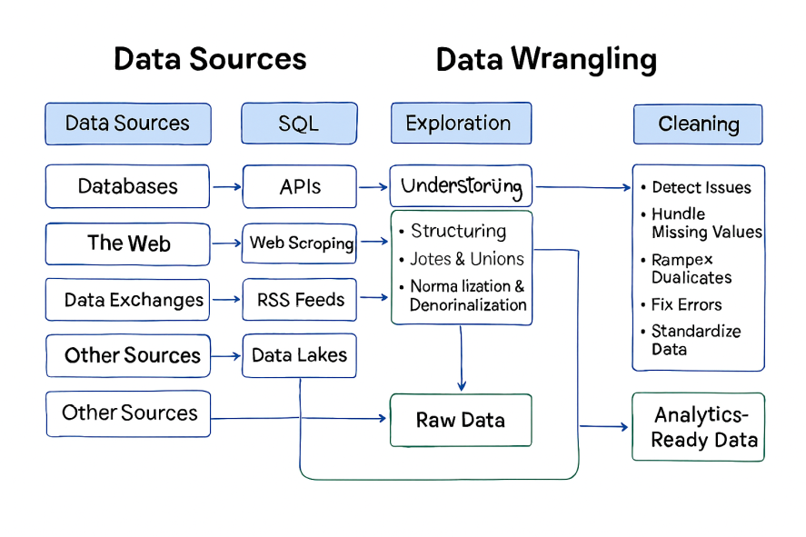

**🗺 Pipeline Stages in the Diagram**

1. **📂 Data Sources**
   * **Databases** (RDBMS, NoSQL)
   * **APIs** (public, private, validation services)
   * **Web Scraping** (HTML pages, media)
   * **RSS Feeds** (news, forums)
   * **Data Streams** (IoT, GPS, social feeds)
   * **Data Exchanges** (AWS, Snowflake, Crunchbase)
   * **Other Research Data** (Gartner, Forrester, surveys)
2. **🔌 Gathering Methods**
   * **SQL / CQL / GraphQL** queries
   * **API calls & endpoints**
   * **Scraping / harvesting scripts**
   * **Feed capture tools**
   * **Streaming pipelines**
   * **Exchange protocols & standards**
3. **📦 Storage Repositories**
   * **Relational DBs** → structured only
   * **NoSQL DBs** → structured + semi‑structured
   * **Data Lakes** → all data types & schema‑on‑read
4. **🏗 Wrangling Steps**
   * **Structuring** (joins, unions, schema alignment)
   * **Normalization / Denormalization**
   * **Issue Detection** (profiling, visualization)
   * **Cleaning & Standardization** (missing values, duplicates, irrelevant data, type conversions, format unification, syntax fixes, outlier handling)
5. **📊 Analytics‑Ready Output**
   * Unified, validated, and standardized dataset ready for **BI dashboards, ML models, and data science workflows**.

Here’s a **structured, concise set of notes** from your lecture on **Popular Data Wrangling Tools** — designed so you can quickly compare and recall their capabilities.

## 🛠 ****Popular Data Wrangling Tools****

### 1. ****Spreadsheets + Add - ins****

* **Examples**: Microsoft Excel, Google Sheets
* **Features**:
  + Built‑ in formulas for identifying issues, cleaning, transforming data.
  + Add‑ ins for importing from various sources:
    - **Excel** → Power Query
    - **Google Sheets** → Query function
* **Best For**: Manual wrangling of small to medium datasets.

### 2. ****Open Refine****

* **Type**: Open‑ source
* **Capabilities**:
  + Import/export in TSV, CSV, XLS, XML, JSON.
  + Clean, transform, and extend data with web services/external datasets.
  + Menu‑ based interface — no command syntax needed.
* **Strength**: Easy to learn, flexible format handling.

### 3. ****Google Data Prep****

* **Type**: Intelligent, fully managed cloud service.
* **Capabilities**:
  + Visual data exploration and cleaning for structured + unstructured data.
  + Automatic detection of schema, data types, anomalies.
  + Guided suggestions for next steps.
* **Advantage**: No install or infrastructure management.

### 4. ****Watson Studio Data Refinery**** (IBM)

* **Capabilities**:
  + Discover, cleanse, transform large datasets.
  + Explore across diverse data sources.
  + Auto ‑detect data types/classifications.
  + Enforce governance policies automatically.
* **Ideal For**: Enterprises needing governance + transformation in one tool.

### 5. ****Trifacta Wrangler****

* **Type**: Interactive cloud ‑based service.
* **Features**:
  + Cleans/restructures messy real‑ world data into tables.
  + Exports to Excel, Tableau, R.
  + Collaboration support — multiple users at once.
* **Best For**: Team‑ based cloud workflows.

## 💻 ****Programming-Based Wrangling****

### ****Python Ecosystem****

* **Jupyter Notebook** → Interactive cleaning, transformation, modeling, visualization.
* **NumPy** → Multi‑dimensional arrays/matrices + math functions.
* **Pandas** → High‑level, fast data analysis (merge, join, transform in single lines); prevents misalignment errors.

### ****R Ecosystem****

* **dplyr** → Simple, powerful syntax for wrangling.
* **Data table** → High‑ speed aggregation for large datasets.
* **jsonlite** → Robust JSON parsing, ideal for web APIs.

## 📌 ****Tool Selection Factors****

* Supported **data size** & **structures**.
* Cleaning & transformation **capabilities**.
* **Infrastructure** needs (cloud, on‑prem, managed service).
* **Ease of use** & **learning curve**.
* **Collaboration** features for teams.

## 📊 Popular Data Wrangling Tools — Comparison Matrix

| **Tool / Platform** | **Deployment Type** | **Typical Data Size** | **Data Types Supported** | **Key Strengths** | **Ease of Use / Learning Curve** | **Collaboration & Governance** |
| --- | --- | --- | --- | --- | --- | --- |
| **Excel / Google Sheets (+ Add‑ins)** | Desktop / Cloud | Small–Medium | Mostly structured | Quick manual cleaning, formulas, easy add‑ins | Very easy — familiar UI | Limited collaboration (Sheets better in cloud) |
| **OpenRefine** | Desktop | Small–Medium | Structured + semi‑structured | Wide format support (CSV, TSV, JSON, XML), menu‑based ops | Easy — no coding needed | Single‑user focus |
| **Google DataPrep** | Cloud, fully managed | Small–Large | Structured + unstructured | Auto schema/type detection, step suggestions | Very easy — guided interface | Strong — built for multi‑user |
| **IBM Watson Studio – Data Refinery** | Cloud / Enterprise | Medium–Large | Structured + semi‑structured | Governance enforcement, wide source access, automated profiling | Moderate — enterprise‑grade tool | Strong governance + compliance |
| **Trifacta Wrangler** | Cloud | Small–Large | Structured + semi‑structured | Interactive cleaning, exports to BI tools, real‑time collaboration | Easy to moderate | Excellent — real‑time multi‑user |
| **Python (Jupyter, NumPy, Pandas)** | Local / Cloud | Any (scales with infra) | Structured, semi‑structured, some unstructured | Automation, complex transformations, reproducibility | Moderate–Hard (needs coding) | Strong via code repos & notebooks |
| **R (dplyr, data.table, jsonlite)** | Local / Cloud | Any (scales with infra) | Structured, semi‑structured, JSON | High‑performance aggregation, tidy syntax, API JSON handling | Moderate–Hard (coding) | Strong via code versioning |

💡 **Tip for selection**:

* For **quick ad‑hoc** cleanup → Excel/Sheets or OpenRefine.
* For **guided, visual wrangling at scale** → Google DataPrep or Trifacta.
* For **enterprise governance & compliance** → IBM Data Refinery.
* For **maximum flexibility, automation & scalability** → Python or R.

**Basic Querying Techniques for Analyzing Data** —

## 📌 Purpose

* Query languages help **access and understand data** in databases.
* Techniques apply to:
  + **SQL** (RDBMS)
  + SQL‑like query languages (**CQL**, **Cypher**, etc.)
  + APIs for querying data

## 🛠 Core Querying Techniques

### 1. ****Counting Records****

* **COUNT()** → total rows in dataset
* **DISTINCT()** → unique values in a column
* **COUNT(DISTINCT …)** → unique count
* Example: COUNT(DISTINCT dealer_id) = 8 unique dealers

### 2. ****Aggregations****

* **SUM()** → total of numeric column
* **AVG()** → average value
* **STDDEV()** → measure spread/dispersion
  + High value → wider spread
  + Example: Avg used car cost ≈ $6K; high std. deviation due to outliers

### 3. ****Identifying Extremes****

* **MAX()** → highest value in column
* **MIN()** → lowest value in column
  + Example: MAX = $37K, MIN = $1K

### 4. ****Slicing (Conditional Retrieval)****

* Filter based on one or more conditions
* Operators: BETWEEN, AND, OR
* Example: Customers spending $1K–$2K **and** in specific area

### 5. ****Sorting****

* **ORDER BY** → arrange in ascending (ASC) or descending (DESC) order
* Use for trend identification (e.g., sales during festivals)

### 6. ****Pattern Filtering****

* **LIKE** → partial matches
  + % = wildcard (any number of characters)
  + _ = single character wildcard
* Example: Match pin codes starting with first 3 digits

### 7. ****Grouping & Aggregating****

* **GROUP BY** → aggregate metrics per group
* Combine with aggregates (SUM, COUNT, AVG)
  + Example: Total spent by customers **per pin code**

## 🗂 Quick Reference Table

| **Task** | **SQL Function/Operator** | **Example Purpose** |
| --- | --- | --- |
| Count rows | COUNT() | Total sales records |
| Count uniques | COUNT(DISTINCT col) | Unique customers |
| Sum values | SUM() | Total revenue |
| Average | AVG() | Avg. order value |
| Spread | STDDEV() | Variation in prices |
| Max/Min | MAX(), MIN() | Highest/lowest sale |
| Conditional filter | WHERE, BETWEEN, AND, OR | Slice dataset |
| Sort results | ORDER BY | Rank sales by date |
| Pattern match | LIKE | Match zip codes starting with “123” |
| Group & aggregate | GROUP BY + aggregate | Sales by region |

**Performance Tuning & Troubleshooting in Data Engineering :** —

## 🎯 Purpose

* Ensure **data pipelines** and **databases** run **efficiently**, remain **available**, and scale with demand.
* Performance issues can arise **anywhere** in the lifecycle — from source ingestion to delivery.

## 🚧 Common Performance Threats in Data Pipelines

| **Threat** | **Example Impact** |
| --- | --- |
| **Scalability limits** | Larger datasets slow processing |
| **Application failures** | Components crash, halting pipeline |
| **Job scheduling issues** | Dependencies not met, jobs out of order or skipped |
| **Tool incompatibilities** | Mismatched versions or unsupported features |

## 📊 Key Performance Metrics

### ****For Data Pipelines****

* **Latency** → time to fulfill a request
* **Failure rate** → proportion of failed requests
* **Resource utilization** → CPU, memory, I/O patterns
* **Traffic** → requests per time period

### ****For Databases****

* **System outages** & downtime
* **Capacity utilization**
* **Application slowdown**
* **Query performance**
* **Conflicting workloads** (batch jobs vs interactive queries)

## 🛠 Generic Troubleshooting Flow

1. **Gather information**
   * Confirm the anomaly is real, not just perception
   * Check alerts, user reports, maintenance logs
2. **Check environment consistency**
   * Versions of software, configs, and source code
   * Note recent deployments/changes
3. **Inspect logs & metrics** early
   * Look for error messages, spikes in load, CPU, memory
4. **Isolate the cause**
   * Determine if it's infra, data, software, or hybrid issue
5. **Reproduce in test environment** if unclear
   * Validate root cause hypothesis via controlled experiments
6. **Deploy fix to production** following team process

## ⚙ Database Optimization Best Practices

| **Technique** | **Benefit** |
| --- | --- |
| **Capacity Planning** | Ensures enough resources now & for growth |
| **Indexing** | Faster data retrieval, fewer disk reads |
| **Partitioning** | Breaks big tables → smaller, more manageable chunks |
| **Normalization** | Reduces redundancy, avoids anomalies, improves query & update efficiency |

## 📡 Monitoring & Alerting Tools

* **Database Monitoring** → periodic snapshots of key performance indicators
* **Application Performance Management (APM)** → track request time, errors, resource usage
* **Query Performance Monitors** → throughput, execution stats, resource demand
* **Job-level Runtime Monitoring** → monitor completion time for each pipeline stage
* **Workload Monitoring** → track data volume processed for performance impact

## 🛡 Preventive Maintenance

* **Time-based** → scheduled at fixed intervals
* **Condition-based** → triggered by specific faults or performance drops

### 🧠 Quick Visual Flow (Pipeline Troubleshooting)

Alert/User report

↓

Verify issue → Check versions/configs

↓

Review logs & metrics

↓

Infra/Data/Software isolation

↓

Reproduce in test → Hypothesis validation

↓

Apply & monitor fix in prod

**Data Governance & Compliance** : -

## 📌 ****Definition****

* **Data Governance** = Principles, practices, and processes to **maintain security, privacy, and integrity** of data throughout its lifecycle.
* **Framework** covers **technologies, databases, and data models**.
* **Primary focus**: Protecting **personal and sensitive data**:
  + Identifiable data (name, ID)
  + Sensitive categories: race, sexual orientation, genetic info.

## 🌍 ****Key Regulations****

| **Region / Sector** | **Regulation** | **Purpose** |
| --- | --- | --- |
| **EU** | **GDPR** | Protects EU citizens’ personal data & privacy |
| **US - State** | **CCPA** (California) | Consumer data protection |
| **Healthcare** | **HIPAA** | Protects health info |
| **Retail** | **PCI DSS** | Governs credit card data |
| **Finance** | **SOX** | Regulates handling/reporting of financial info |

## 📜 ****Compliance****

* Ongoing process ensuring **legal & ethical** operations.
* Requires:
  + **Controls and checks**
  + **Audit trail** to prove compliance
* **Non-compliance risks**:
  + Financial penalties
  + Loss of trust & reputation
* Must blend **people + process + technology**.

## 🔄 ****Data Lifecycle & Governance Considerations****

1. **Data Acquisition**
   * Legal basis (contracts, consent)
   * State **purpose** (privacy policy)
   * Minimize collected data (only what’s needed)
2. **Data Processing**
   * Define processing details & purpose
   * Establish legal basis (contract/consent)
3. **Data Storage**
   * Location & infrastructure security measures
   * Prevent internal/external breaches
4. **Data Sharing**
   * Identify vendors with access
   * Enforce contractual compliance
5. **Data Retention & Disposal**
   * Define retention/deletion policies
   * Ensure complete removal (incl. third parties)
6. **Auditable Trail**
   * Track acquisition, processing, storage, access, retention, deletion

## 🛡 ****Controls & Technologies****

### 1. ****Authentication & Access Control****

* Multi-layer (passwords + tokens + biometrics)
* Role-based access for systems & data objects

### 2. ****Encryption & Data Masking****

* **Encryption**: For data **at rest** & **in transit**
* **Masking**: Anonymization (hide data in UI), Pseudonymization (replace IDs with artificial values)

### 3. ****Hosting & Data Residency****

* Comply with cross-border transfer laws (on-prem or cloud)

### 4. ****Monitoring & Alerting****

* **Security monitoring**: Track access & activity
* **Audit reports**: For compliance & investigation
* **Alerts**: Triggered by severity & urgency

### 5. ****Data Erasure****

* Overwrite data to permanently remove (more secure than deletion)

✅ **Key Takeaway**:  
Data governance isn’t just about tools — it’s a **continuous, transparent process** that aligns **legal, ethical, and technical practices** to protect sensitive data at every stage.

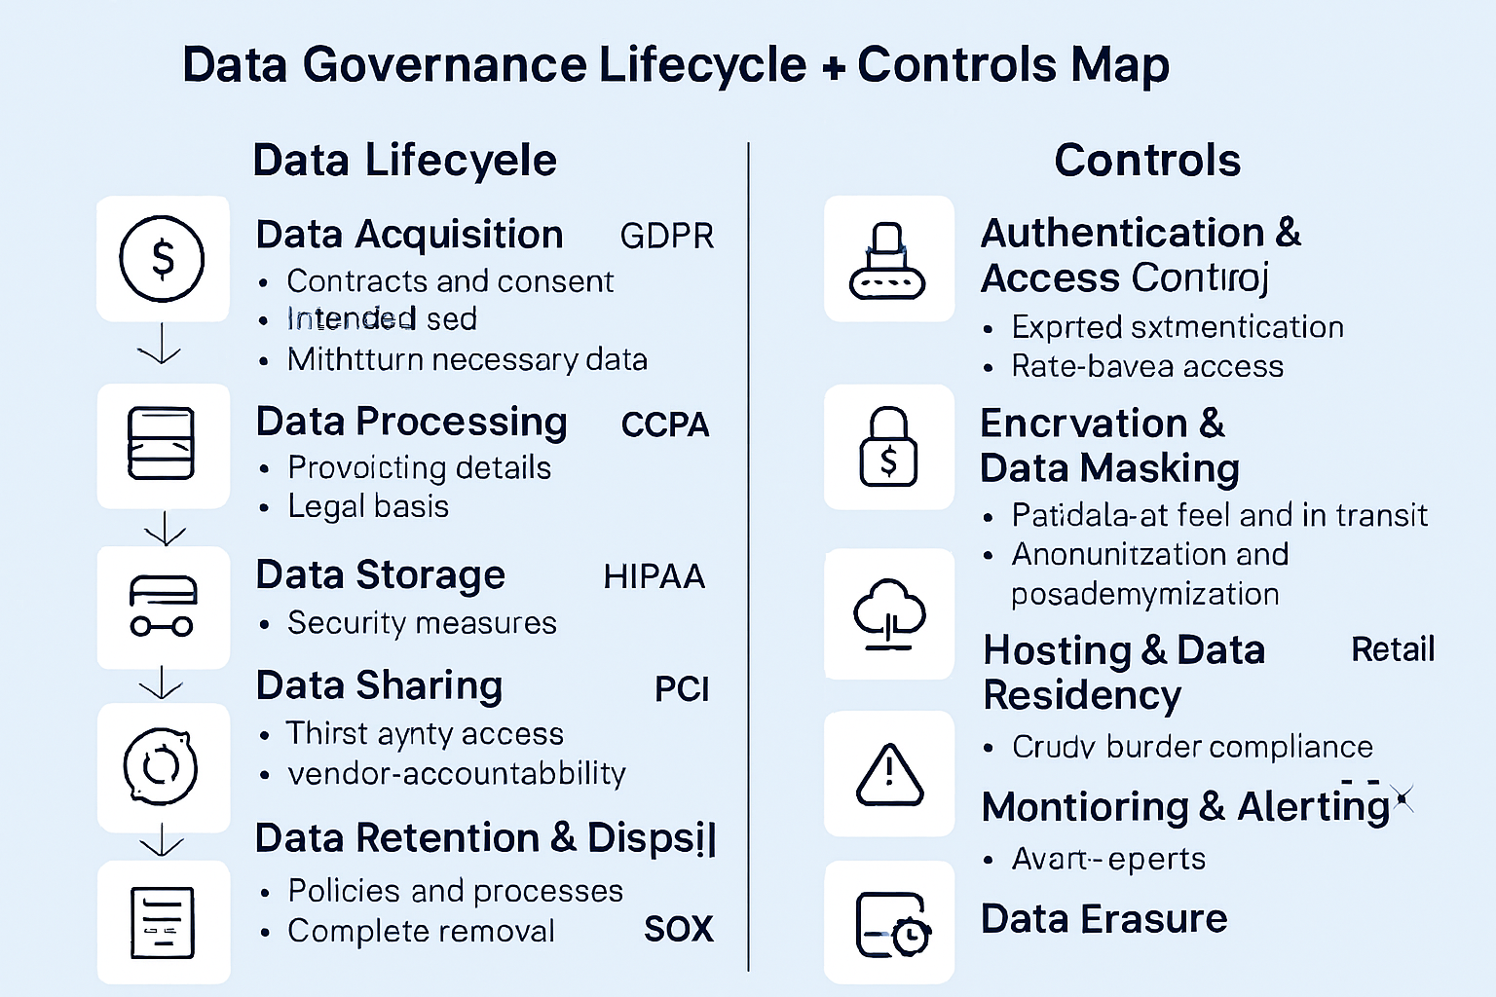

Your **extended Data Governance Lifecycle + Controls Map** is ready — now with **industry-specific overlays** so you can see exactly how regulations like **HIPAA**, **PCI DSS**, and **SOX** align with lifecycle stages and the matching technical controls.

**🗺 How to Read the Extended Map**

* **Left Column (Lifecycle)** → The 6 governance stages from *Acquisition* to *Retention & Disposal*.
* **Middle Overlay (Industries)** → Examples of how **sector‑specific regulations** apply at that stage.
* **Right Column (Controls)** → The core governance tools & practices that enforce compliance.

**Example Mappings in the Extended Chart**

* **Retail (PCI DSS)** →
  + *Acquisition*: Collect only necessary cardholder data.
  + *Processing*: Enforce encryption for credit card info in all transactions.
  + *Storage*: Mask or tokenize PAN numbers; strict access control.
* **Healthcare (HIPAA)** →
  + *Processing*: Maintain PHI confidentiality with encryption + audit trails.
  + *Sharing*: Business Associate Agreements for vendors.
  + *Retention/Disposal*: Secure PHI erasure per HIPAA retention periods.
* **Finance (SOX)** →
  + *Storage*: Audit-ready logs for all financial data changes.
  + *Sharing*: Limit access to financial reports and sensitive ledgers.
  + *Retention*: Retain financial records for mandated periods; secure disposal thereafter.

This version acts as a **multi‑layer cheat sheet** — you can trace:

1. **Lifecycle stage** →
2. **Industry‑ specific compliance mandate** →
3. **Technical control(s) used to meet it**

;